**OMIS 690 Project Scheduling Assignment**

**Team Members(Group-9)**

Srikruthi Tripuraneni (Z1972432)  
Reethika Bollaboyana (Z1973175)  
Venkata Sidhartha Bollaboyana (Z1975468)

**Task Table**

**Gantt Chart**

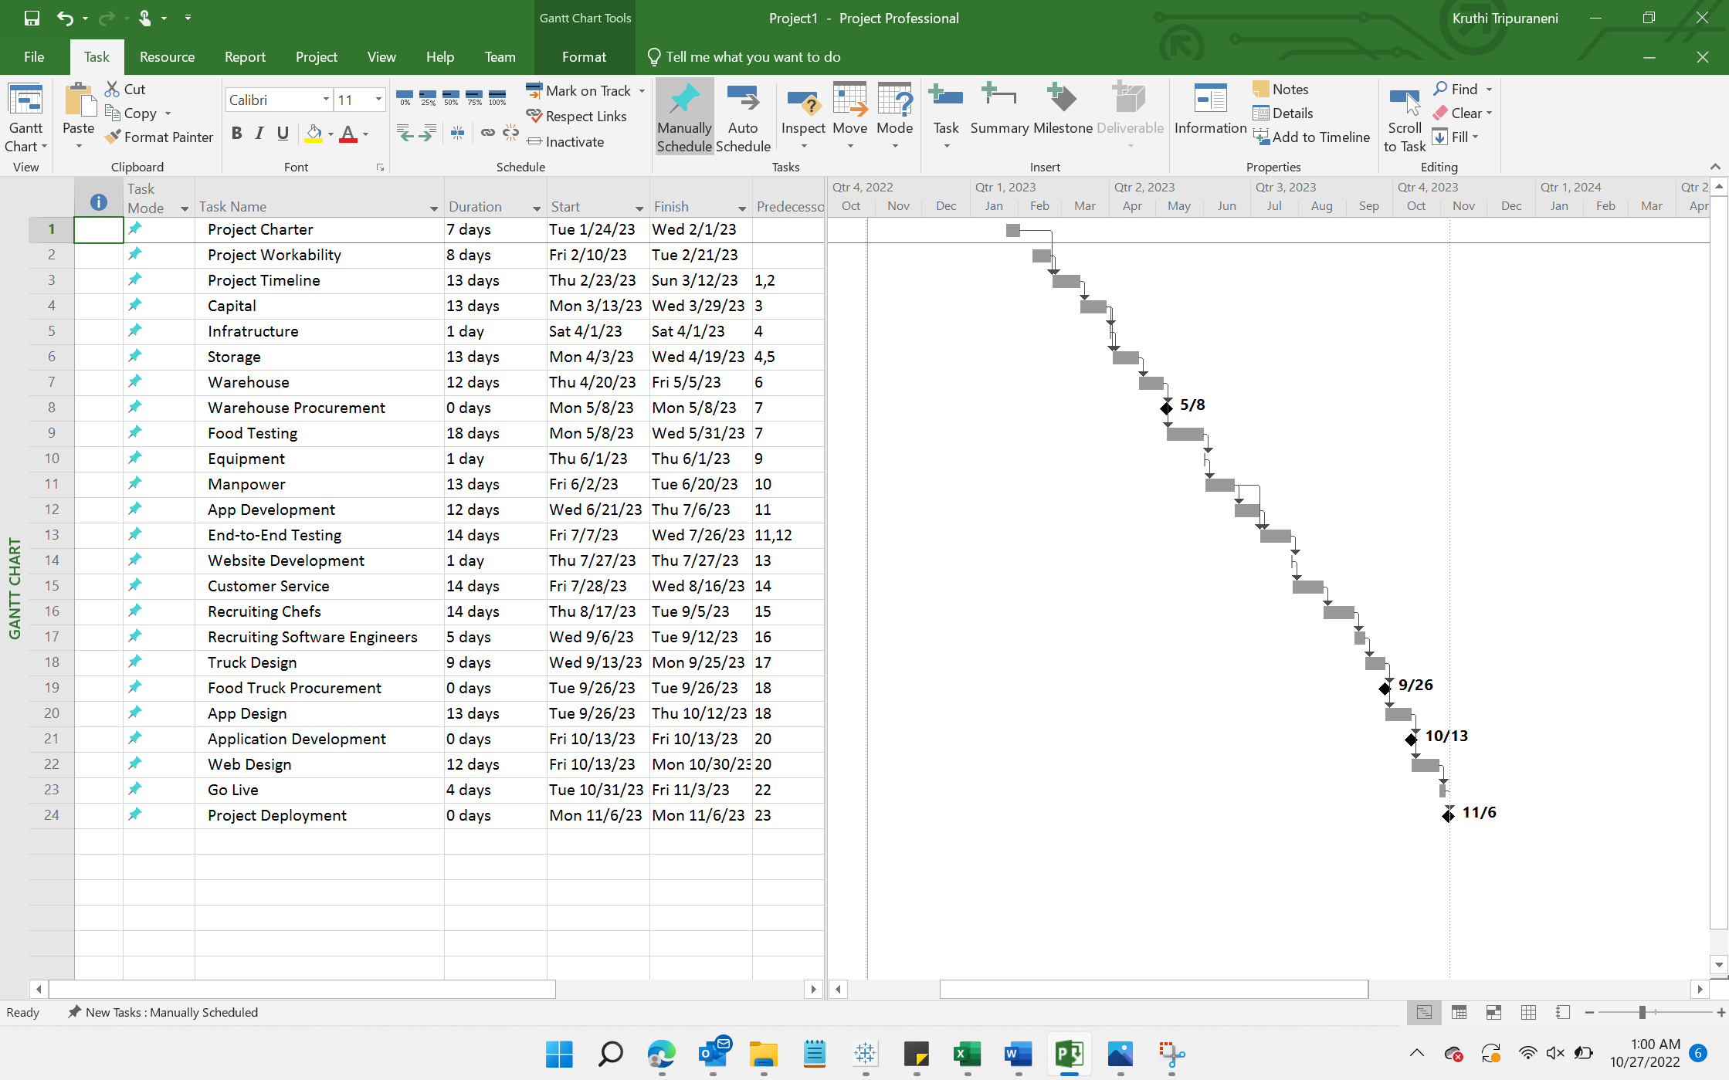

**Network Diagram**

